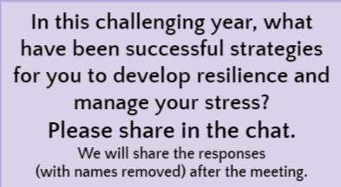**May 17, 2021 CIT Mentor Forum “Chat”**

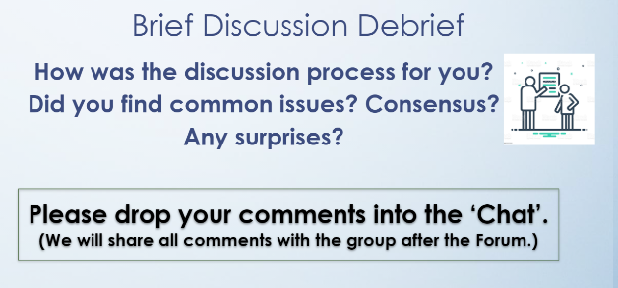

***Find Breakout Room “Discussion Debrief” chat comments by clicking*** ***here******.***

* Gratitude journal
* Self-care and encouraging others to do the same
* things I learned in the Onward PD with Annamaria
* reminders to take one step at a time - try one thing, then try the next...patience
* extra dog walks
* Knowing that there is always someone to reach out when you hit a bump.
* Not answering emails on Saturdays
* Talk with trusted coworkers
* Giving myself and others patience and some grace.
* On remote days - taking a walk during lunch; talking to a trusted group of friends at work
* Entertaining with close friends.
* Scheduling "me" time into my daily schedule to create balance; not answering (or answering very little) work related emails and text over the weekend/ after a certain time each night.
* Exercise, spending time with friends and family.
* Listen to music while journaling
* Wine 🍷
* Breathe especially when your plate is full and overwhelming.
* getting outside or opening windows whenever possible
* Me time is always good throughout the day..
* wine and exercise
* Not opening my computer after hours.
* watching comedies and comedians
* Are we allowed to say wine?! Asking for a friend…
* exercise
* and wine
* chatting with friends
* and wine
* Long walks
* and wine
* Jogging and soccer
* Fresh air and family
* Long walks.
* being willing to accept what my students and their families were able to give-
* a combination of exercise, chocolate and wine
* Spending time with friends and family. And a chosen Sunday each month with NO electronics on in the house
* Walking.
* Taking one day at a time
* Massage every week.
* Letting go a bit more than usual...
* Trying to suspend judgement on myself, colleagues, students and families.
* realizing what is within my locus of control and what isn't and acting accordingly
* exercise
* church
* Limiting my screen time outside of school. Planning strategically and ahead of time.
* Stopped watching the news, retail therapy and many nature walks
* To-do lists & nature.
* Getting outside
* The importance of taking exercise breaks, especially when tied to a computer all day.
* home projects
* deleting social media
* Understanding that we are all in this together - the whole world - and focusing on the good things
* Exercising outside and limiting work outside of school hours
* Dog walks and cooking
* Prayer, Bible reading, exercise, and eating comfort foods
* Painting
* Painting
* Take deep breaths, take it one day at a time.
* Getting outdoor as much as possible and stick to a routine
* reading, prayer, exercise
* Definitely getting outside as much as possible.
* exercise....hiking...time with loved ones
* Home projects and cleaning out old stuff
* Nature, music, laughing w family and friends
* family and friends
* joined a women’s hiking group in Naples NY; they also do yoga in the park
* Kittens
* Asking myself “Is this worth stressing over? In the BIG picture does this matter?” And then adjusting to exert energy where needed
* helping others feel better
* Going for walks
* looking for things to be grateful for!
* Celebrating success no matter how insignificant it seems, finding joy in unlikely places, listening more carefully to nature.
* The students and I made a garden in a fire pit in our classroom and do mindfulness activities from our socially distanced camping chairs
* mental health
* relationships are vital - they MUST be built

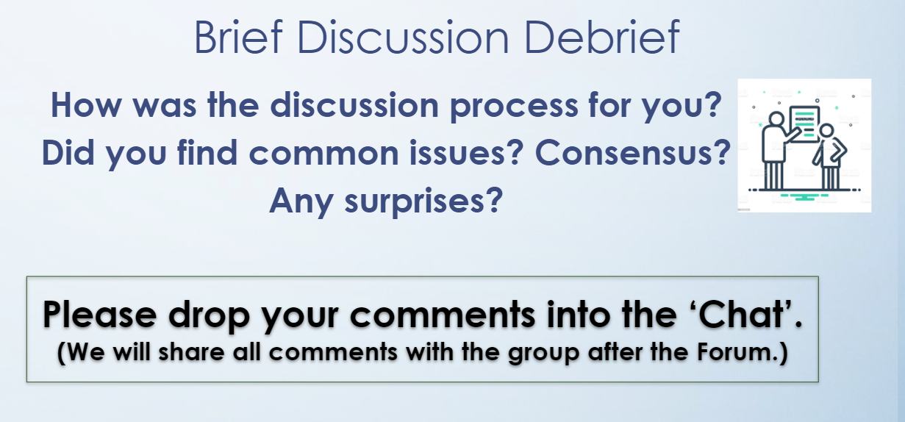

* Are we ready to go back as educators. we are not the same after this pandemic. We need help too.
* We had very similar discoveries- relationship building is the key to everything
* We had a range from pre-k to high school perspectives yet still had the same take aways.
* Team members worked and shared together. We had some of the same concerns/thoughts
* It was good to make the breakout groups small, that allowed each person to contribute
* common issues for sure - even across grade levels and subject areas
* It’s easier to have rich discussions in a smaller setting.
* Discovered similarities with relationship building and flexibility
* Very difficult this year going into a new building with no relationships. Relationships is key
* Speaking from experience offers so much to discuss as opposed to speaking about an article that we may or may not relate to.
* We had so much to share!